

**1.0 Getting Started**

**The basics of the system**

**Summary**

The aim of this tip sheet is to guide you through the basics of the system. This includes how to access the system, changing your username and password, navigating between modules, exporting data and logging out.

**How do I access the system?**

To access the system, go to [www.s2riskwise.co.uk](http://www.s2riskwise.co.uk). Click ‘login’.  
  
A new popup will appear showing the login screen. The first time you access the system, you will be requested to enter you Company ID. Once entered press ‘proceed’. Once you have entered this the first time, your computer should remember it for you.  
  
You will then be prompted to enter your username and password. Once entered, click ‘proceed’, and the system will then go on to load your default landing page.

**How do I change my username and/or password?**

To change your username and/or password, click on your name, which is always displayed in the top right hand corner of the screen.

The ‘user settings’ popup will then appear.

The fourth text box down will display your

existing username and will allow you to

overtype with a new username.  
  
To change your password, click the ‘change

password’ tick box. This will then display the

password text field. This will be blank, allowing

you to enter a new password, which must be

a minimum of eight characters, including text

and numeric’s. Once complete, press ‘save’.

**How do I navigate between modules?**

To navigate between modules, you can use the module selection drop down, found on the coloured menu bar, in the top right of the screen, just beneath your username.

Clicking the dropdown will display the available modules which

you can navigate to. Selecting a module will refresh your screen

and load the different module. The system will try to keep you in

as close a screen as possible, to what you were already in.

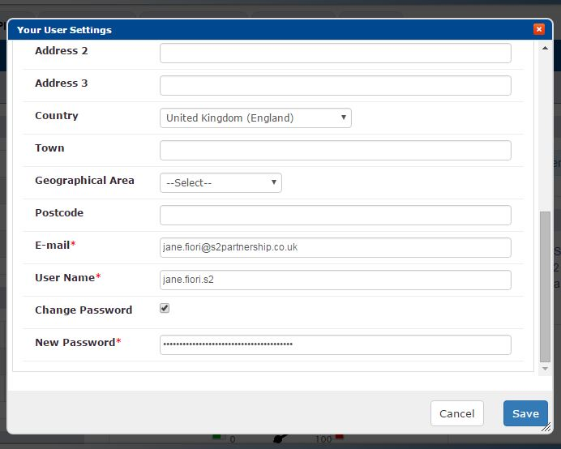



**How can I export data into Microsoft Excel?**

Almost any data within the system can be exported into a spreadsheet format. The export facility can be accessed from either the ‘export screen data’ or ‘export all data’ buttons, both found on the lower light blue menu bar.

‘Export screen data’ will take the data that is currently displayed on the screen, and display it in Excel. ‘Export all data’ will take all of the data, from that view of functionality, regardless of how many pages on screen it has been paginated in to, and display it all in Excel. This feature does require browser popups, but if popups are not allowed on your machine, it would be recommended to increase the amount of data displayed on the screen, and then to use the ‘export screen data’ facility.

**How do I log out of RiskWise?**

To log out of the system, simply click ‘log out’ found on

the right hand side of the upper light blue menu bar.

You will then be taken back to the main login screen.

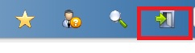

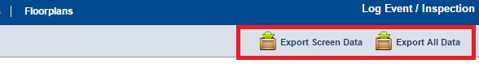

**Need more information?**

**All of the knowledgebase articles can be found at** [**http://support.s2riskwise.com**](http://support.s2riskwise.com)

**Other useful tip-sheets available include:**

* + Property Basics
  + Progressing and Completing Actions
  + The Year Planner